

American International University-Bangladesh (AIUB)
Department of Computer Science
Faculty of Science & Technology (FST)
Fertiware: Streamlining Fertilizer Distribution
A Software Requirement Engineering Project Submitted
By
Semester: SPRING_23_24 |  | Section: D | Group Number:06
SN | Student Name | Student ID | Contribution in %  (CO+CO2) | Individual  Marks
05 | NANIN SULTANA JUI | 19-41495-3 | 10%
08 | MD.DAUD HOSSAIN SUPTO | 20-42806-1 | 22%
15 | SHORBANI CHOWDHURY | 21-44378-1 | 33%
16 | AL FESANI | 21-44381-1 | 35%

The project will be Evaluated for the following Course Outcomes

EVALUATION CRITERIA | Total Marks (50)
Introduction, Format, Submission, Defense | [10 Marks]
System Overall Description & Functional Requirements | [10 Marks]
System Quality Attributes and Project Requirements | [10 Marks]
UML and E-R Diagram with Data Dictionary | [10 Marks]
UI/UX Prototyping | [10 Marks]

Software Requirements Specification

for

< Fertiware: Streamlining Fertilizer Distribution>
Fertiware_v_1.0
Prepared by <Fesani,Al,Chowdhury,Shorbani,Supto,Md.Daud Hossain,Jui,Naznin Sultana>
<American International University-Bangladesh (AIUB)>
<May 11,2024>

Table of Contents
Revision History 3
1. Introduction 4
1.1 Purpose 4
1.2 Document Conventions 4
1.3 Intended Audience and Reading Suggestions 5
1.4 References 6
2. Overall Description 6
2.1 Product Perspective 6
2.2 Product Functions 7
2.3 User Classes and Characteristics 8
2.4 Hardware and Operating Environment 9
2.5 Design and Implementation Constraints 9
2.6 User Documentation 9
3. System Requirements 11
3.1 System Features 11
3.2 Non-Functional/Quality Requirements 13
3.3 Project Requirements 14
4. Design and Interface Requirements 16
4.1 UML Diagrams 16
4.2 Data Dictionary 19
4.3 UI/UX Design Specification 20

Revision History
Name | Date | Reason for Changes | Version

Introduction

Purpose
Firmware aims to address the inefficiencies and lack of transparency in the fertilizer distribution process. By providing a comprehensive platform for fertilizer distribution warehouses, it seeks to streamline inventory management, transactions, and distribution processes. The software also aims to ensure timely and reliable delivery of fertilizer to farmers, thereby enhancing crop yields and overall agricultural productivity. Ultimately, Firmware aims to increase profitability for fertilizer distribution warehouses while improving the quality of service for farmers.
The scope of Firmware encompasses various aspects of the fertilizer distribution process, including inventory management, transaction tracking, delivery scheduling, and farmer outreach. It provides a centralized platform for distributors to manage their operations efficiently, from tracking stock levels to monitoring delivery performance. Additionally, the software includes features such as employee management and task tracking to enhance accountability and transparency within distribution companies. The scope also extends to providing valuable insights and analytics to support data-driven decision-making and continuous improvement.
The business requirements for the fertilizer distribution firmware aims to revolutionize the industry by addressing key challenges faced by distributors and farmers alike. With efficient inventory and transaction management tools, the software will enable distributors to streamline their operations, reduce waste, and maximize profitability. Timely and accurate delivery of fertilizer to farmers will be ensured through an optimized distribution process, enhancing farmer satisfaction and productivity. Transparency and accountability will be at the forefront, with the ability to track stock levels, transactions, and employee tasks accurately. Real-time data and insights into inventory, transactions, and delivery schedules will empower distributors to make informed decisions and adapt to changing circumstances. Moreover, the firmware will facilitate direct communication between distributors and farmers, fostering reliable and timely delivery of fertilizer and nurturing long-term relationships. Notably, the project will follow an incremental software development model, allowing for iterative development and release of functional subsets, ensuring flexibility, adaptability, and efficient resource utilization throughout the development process.

Document Conventions
The following document conventions are intended to preserve coherence and clarity throughout the SRS of " The fertilizer distribution firmware "
Font Style and Size:
- For uniformity and readability, the Times New Roman font in a 12-point size is used throughout the document
Headings:
- To ensure clear identification, major headings are supplied in bold text
- Subheadings are written in bold utilizing sentence case to effectively define distinct sections.
Prioritization of Requirements:
- The client designates a specific priority level for each requirement statement in the document.
- The priority levels for higher-level requirements do not carry over to detailed requirements, guaranteeing clear prioritizing.
Use of Formatting:
- System terminologies, user interface elements, and system components. For clarity, functions are highlighted with bold type.
- Italics is used to indicate references to external publications or standards.
- For ease of identification, hyperlinks inside the SRS to relevant documents or external resources are highlighted.
Numbering of Requirements:
- For better organization and referencing, each requirement is organized hierarchically and uses a numbered system (e.g., Major Requirement, Minor Requirement, Sub-Minor Requirement - formatted as 1.1)
These guidelines are intended to improve the SRS's readability, structure, and general comprehension for all project participants.

Intended Audience and Reading Suggestions
Intended Audience for the document:
- Developers: This document provides guidance for developers so they may fully understand the needs of the system and add the features that are required
- Project managers: By using this document, project managers will be able to comprehend the project's scope, calculate the resources needed, and monitor the project's advancement.
- Testers: This document will be used by testers to create and carry out test cases to verify if the software complies with the required specifications. comprehension of the SRS for project stakeholders.
- Documentation Writers: This document will be consulted by writers of user manuals and other user-oriented documentation to ensure that the capabilities and functionalities of the system are appropriately depicted.
- Users: By gaining access to this document, users will be able to better understand the software by learning about its features, capabilities, and intended usage

Suggestions for Reading the Document:
- Overview Sections: Start with the sections that give a general overview of the software, outlining its objectives, target market, and purpose. This provides a high-level comprehension of the undertaking
- Functional needs: To comprehend the precise features and functionalities the software must have; developers should read through the functional requirements section.
- Non-Functional Requirements: project managers, developers, and testers will find information on security, performance, and other non-functional requirements
- Project Management and Resource Estimation: To effectively manage the project, project managers should concentrate on the parts pertaining to project scope, resource estimation, and progress tracking
- User-Facing Documentation: To build user-friendly documentation, documentation writers and users should consult the sections describing the features, functionalities, and intended use of the product.

References
- How to Write a Software Requirements Specification (SRS) Document. Available at: SEI Digital Library (cmu.edu)
- V. R. Chavan, P. N. Mahajan, and R. R. Deshmukh, "Fertilizer inventory management system using IoT and machine learning," in Proc. IEEE Int. Conf. Inventive Comput. Technol. (ICICT), Pune, India, 2020, pp. 258-263.
- Software Requirement Specification (SRS) Format. Available at: https://www.geeksforgeeks.org/software-requirement-specification-srs-format/

Overall Description

Product Perspective
"Firmware" is a revolutionary, standalone software program created to tackle the persistent problems in the fertilizer supply chain. This cutting-edge platform is designed to give fertilizer distribution warehouses a full range of tools to manage inventory, streamline transactions, and improve distribution procedures without being restricted by current systems or product lines. "Firmware" aims to increase crop yields and overall agricultural output by guaranteeing farmers receive fertilizer delivery that are both timely and trustworthy. With its innovative methodology, "Firmware" aims to address the shortcomings and ambiguity that have beset the sector, opening the door for a fertilizer supply chain that is more effective, transparent, and optimal.
Context and Origin:
Fertiware incorporates sophisticated route planning and optimization algorithms to streamline delivery operations. Distributors can optimize delivery routes based on factors such as geographical location, order volume, vehicle capacity, and traffic conditions, reducing fuel consumption and delivery times

Product Functions
The primary functions of the "Firmware" software include:

1.Registration:
- Allow registration for both warehouses and farmers
- Collect contact details (name, email, phone number, etc.)
- Collect location information (address, GPS coordinates, etc.)
- Collect business information for warehouses (company name, license, etc.)
- Collect personal information for farmers (name, farm size, etc.)
- Implement secure verification procedures (email/SMS verification, document upload, etc.)
- Ensure data privacy and security for the collected information
2. Inventory Management:
- Add fertilizer products to inventory
- Update product quantities and details
- Real-time monitoring of inventory levels
- Reorder reminders for low stock
- Record incoming goods shipments
- Maintain transaction records
- Reporting on inventory and transactions
3. Order Management:
- Online order placement for farmers
- Match farmer orders with warehouse inventory
- Allow warehouses to accept or reject orders
- Facilitate secure online payments
- Order tracking for farmers
- Order status updates
- Order history and records
4. Distribute Vehicle Assignment:
- Vehicle Assignment: Enable warehouses to assign optimal routes to specific delivery trucks and drivers, ensuring efficient utilization of resources
- Real-time Vehicle Tracking: Provide real-time tracking of delivery vehicles, allowing for monitoring of their location and progress along the assigned routes.
- Estimated Delivery Times: Calculate and provide estimated delivery times for each order, based on the optimized routes, traffic conditions, and other relevant factors.
5. Demand Forecasting:
- rend Identification: Identify trends and patterns in fertilizer demand based on seasonal variations, regional preferences, agricultural practices, and other relevant factors.
- Demand Forecasting: Develop forecasting models and algorithms to project future fertilizer demand, taking into account historical data, market trends, and other relevant factors.
- Inventory Planning Support: Provide warehouses with demand forecasts and recommendations for inventory planning and procurement strategies, enabling them to optimize inventory levels and avoid overstocking or understocking.
6. Analytics and Reporting:
- In-depth Reports: Generate comprehensive reports covering inventory, sales, delivery performance, and financial metrics
- Customizable Dashboards: Allow users to create personalized dashboards displaying relevant metrics and KPIs.
- Decision Support: Provide data-driven recommendations and tools to assist in informed decision-making for inventory management, procurement, and operational optimization.
7. User Management:
- Role-based Access Control (RBAC): Define different user roles such as warehouse administrators, warehouse workers, farmers, and assign appropriate access permissions and privileges to each role
- User Account Management: Enable users to modify their account preferences, personal information, and other relevant data within the system.
- Administrative Controls: Provide warehouse administrators with the ability to manage user access and permissions within their organizations, including adding, modifying, or revoking access for employees or associated farmers.
- Secure Authentication: Implement robust authentication mechanisms, such as multi-factor authentication or single sign-on (SSO) integration, to ensure secure access to the system and protect sensitive data.
8. Integration and Data Exchange:
- Offer APIs for integrating with external systems or data sources.
- Enable warehouses to interface with their existing ERP or inventory management systems
- Support data import/export in common formats.

User Classes and Characteristics
The primary user classes for the "Firmware" software include:
- Warehouse Users: In fertilizer distribution warehouses, administrators and staff are in charge of inventory control, order processing, and distribution activities.
- Farmer Users: Farmers who wish to order and receive fertilizers for their farming operations, either individually or through agricultural organizations.
- Support and Development Team: Group of technical experts in charge of developing, maintaining, and supporting systems
- Administrators: Those have the authority to control user access, system configurations, and general system operations.

Hardware and Operating Environment
The "Firmware" program will essentially function as a web-based platform that can be accessed on a variety of devices (desktops, laptops, tablets, and smartphones) using contemporary web browsers. A scalable database system, web servers, and API integration with outside mapping and geolocation services make up the backend infrastructure.

Design and Implementation Constraint
The design and implementation of the "Firmware" software will be constrained by the following factors:
- Platform constraints: The program needs to be made to function properly across a variety of hardware and operating systems, including desktop, mobile, and online.
- Language requirements: Industry-standard programming languages that are suitable with creating mobile and web apps should be used to construct the software.
- Security constraints: For data encryption, user authentication, and cybersecurity protection, implementation should follow industry-standard security methods.
- Parallel operations constraints: Efficient management of concurrent operations is crucial for the system, particularly when handling inventory updates, order processing, and delivery concurrently.

User Documentation

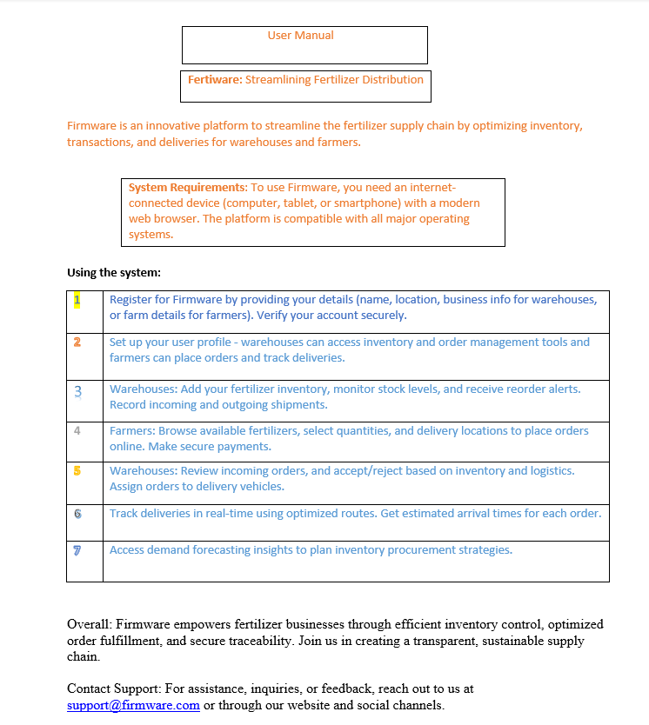

System Requirements

System Features
1. Registration
Functional Requirements (FRs)
  - Users of warehouses may register by giving their contact details, location, and business details.
  - Users of warehouses may register by giving their contact details, location, and business details.
  - A secure verification procedure, such as an OTP or document verification, will be used by the system to confirm the user's identification
  - Users who successfully register will have access to the features specific to their user type (farmer or warehouse) on the site.
Priority Level: High
Precondition: The user has registered in the system.
Cross-references: N/A

- The Management of Inventory
Functional Requirements (FRs)
  - In real time, warehouses can add, update, and monitor their fertilizer inventory.
  - The system will send out reorder reminders and notifications for low stock levels.
  - For the purposes of reporting and auditing, the system will keep a thorough record of every inventory transaction.
Priority Level: High
Precondition: The user is an authorized user of the warehouse
Cross-reference: 1

3.Distribution Scheduling and Enhancement

Functional Requirements (FRs)
3.1. The system will optimize distribution routes and timings based on order locations and warehouse inventory.
3.2 Variables like vehicle capacities, traffic conditions, and distance will be considered by the route optimization algorithm.
3.3 Warehouses can designate the optimal routes for delivery trucks and drivers.
3.4 The system will provide real-time vehicle tracking and estimated delivery timings.

Priority Level: High
Precondition: There are active orders and available inventory.
Cross-references: 2

4.Demand Forecasting
Functional Requirements (FRs)

  - To project future fertilizer demand, the system will examine market patterns and historical data.
  - Demand projections are a useful tool for warehouses to organize their stocking and procurement strategies
  - Based on anticipated demand, the algorithm will suggest the ideal inventory levels.

Priority Level: Medium
Precondition: Sufficient historical data is available.
Cross-references: 2

5.Analytics and Reporting

Functional Requirements (FRs)

  - The system will provide in-depth reports on sales, distribution parameters, transactions, and inventory levels.
  - Customizable dashboards and reports are available for data analysis for warehouses and farms.
  - For well-informed decision-making, the system will offer insights and suggestions based on data analytics.

Priority Level: Medium
Precondition: Relevant data is available in the system.
Cross-references: 2, 3, 4

6. User Management

Functional Requirements (FRs)

6.1. Different user categories (e.g., warehouse administrators, warehouse workers, farmers) will be able to utilize role-based access control within the system
6.2. Users can modify their preferences and account data.
6.3. Within their companies, administrators have the ability to control user access and permissions (warehouses or farmer groups)

Priority Level: Medium
Precondition: The user is a registered user of the system.
Cross-references: 1

7. Integration and Data Exchange
Functional Requirements (FRs)
7.1 APIs (Application Programming Interfaces) for integrating with external systems or data sources will be made available by the system.
7.2 The platform allows warehouses to interface their current ERP (Enterprise Resource Planning) or inventory management systems
7.3 The system will enable data interchange and analysis by supporting the import and export of data in common formats (such as CSV and XML).

Priority Level: Low
Precondition: External systems or data sources are available for integration.
Cross-references: N/A

Non-Functional/Quality Requirements
QA1: Usability: The platform should have an easy-to-use interface that is responsive and tidy, making it less difficult for users with diverse backgrounds to become familiar with it (e.g., farmers, Staff warehouse).
Priority Level: High
Precondition: Users interact with the platform.
Cross-references: N/A
QA2: Performance: The system should respond promptly to user interactions, with a maximum response time of 2 seconds for critical functionalities (e.g., order placement, inventory updates) under normal load conditions.
Priority Level: High
Precondition: The system is operational.
Cross-references: QA4, QA5
QA3: Security: To safeguard user data and guarantee privacy and data integrity, the system should have strong security measures in place. These methods should include data encryption (such as AES-256), secure authentication procedures, and access control mechanisms.
Priority Level: High
Precondition: User data transmission or storage.
Cross-references: N/A

QA4: Availability: Except for planned maintenance tasks, the system should maintain an uptime of at least 99.5%, guaranteeing few service interruptions or outages.
Priority Level: High
Precondition: System operational hours.
Cross-references: QA2
QA5: Scalability: As the platform expands, the system should be scalable enough to accommodate a growing number of users, transactions, and data volumes without sacrificing performance.
Level of Priority: High
Precondition: High user influx or data growth.
Cross-references: QA2
QA6: Reliability: Data integrity and transaction reliability across all functionalities should be ensured by the system's accurate and consistent operation, with few mistakes or failures.
Priority Level: High
Precondition: System operation.
Cross-references: QA3
QA7: Maintainability: To make maintenance, updates, and future improvements easier, the system should be built with modular, well-documented code that complies with industry best practices and standards.
Priority Level: Medium
Precondition: System development and maintenance phases.
Cross-references: N/A
QA8: Compliance: To ensure adherence to legal and regulatory requirements, the system should conform with pertinent legislation, standards, and recommendations connected to the agriculture and distribution industries.
Priority Level: High
Precondition: System deployment and operation.
Cross-references: N/A
QA9: Sustainability: By improving resource use, cutting waste, and limiting the environmental impact of the fertilizer distribution process, the system should support sustainable practices.
Priority Level: Medium
Precondition: System operation.
Cross-references: N/A

Project Requirements
Software Process Model – Incremental Model
Why Incremental Model?
The Firmware platform is being developed using the Incremental Model, which was selected because it is appropriate for projects whose requirements change over time and require regular releases. The fertilizer distribution sector is dynamic, and the platform's needs could alter in response to input from retailers and farmers as well as changes in the market. With the help of the incremental model, the platform may be developed in stages, each of which builds on the one before it to smoothly integrate new features and improvements.
This iterative approach aligns well with the project's objectives of improving transparency, efficiency, and collaboration in the fertilizer distribution process.
Constructive Cost Model (COCOMO):
Constructive Cost Model (COCOMO) for Semi-Detached Software Project:
Let's assume the Source Line of Code (SLOC) for the initial release of Fertiware is 5,000.
Effort needed: PM = 2.4 * (5,000/1000) ^1.05 = 14.07
person-months Development time: DM = 3.0 * (PM)^0.35 = 6.41 months ≈ 7 months Required number of people: ST = PM/DM = 2.20 ≈ 3 people
Based on the COCOMO estimation for a Semi-Detached Software Project, the initial release of Firmware will require approximately 14.07 person-months of effort, with a development time of 7 months, and a team of three people.
Resources Needed for the Project
Human Resources:
- Product Owner: 1 person
- Scrum Master: 1 person
- Developers (Frontend, Backend): 3 persons (as per COCOMO estimate)
- UI/UX Designers: 2 persons
- Quality Assurance/Testers: 2 persons
Hardware and Networking Devices:
- High-performance servers and storage systems for hosting the platform
- Cloud services for scalability and redundancy
- Computers/workstations for development and testing
Reusable Components:
- Frameworks and libraries for order processing, inventory control, user authentication, and data visualization
- Payment gateway integrations
- Mapping and routing APIs for distribution optimization
- UI component libraries for responsive and uniform design;

Design and Interface Requirements

UML Diagrams
ER DIAGRAM
The ER diagram provides a high-level depiction of the data model within the "Fertiware" system, illustrating the relationships and connections between various entities. It offers insights into how different components of the system interact and the type of information that may be stored or associated with each entity.
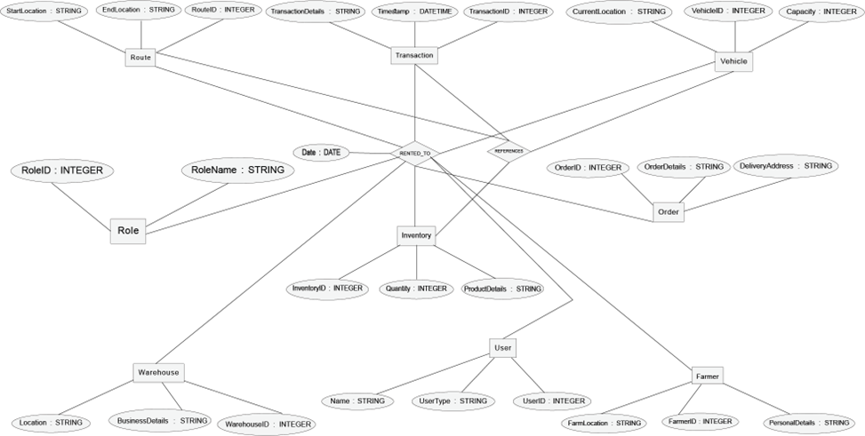
Fig: ER Diagram

Activity Diagram
The provided activity diagram delineates the operational workflows within the "Fertiware" system, catering to distinct user roles: General User, Warehouse Administrator, Farmer, and Admin. Each role initiates its journey with authentication processes, including Registration and Sign-in, ensuring secure access to the system. Once authenticated, General Users and Warehouse Administrators engage in various activities tailored to their roles, such as inventory management, order placement, and transaction processing. Farmers, on the other hand, undertake tasks related to order placement and monitoring. The admin role primarily focuses on managing user accounts and system configurations.
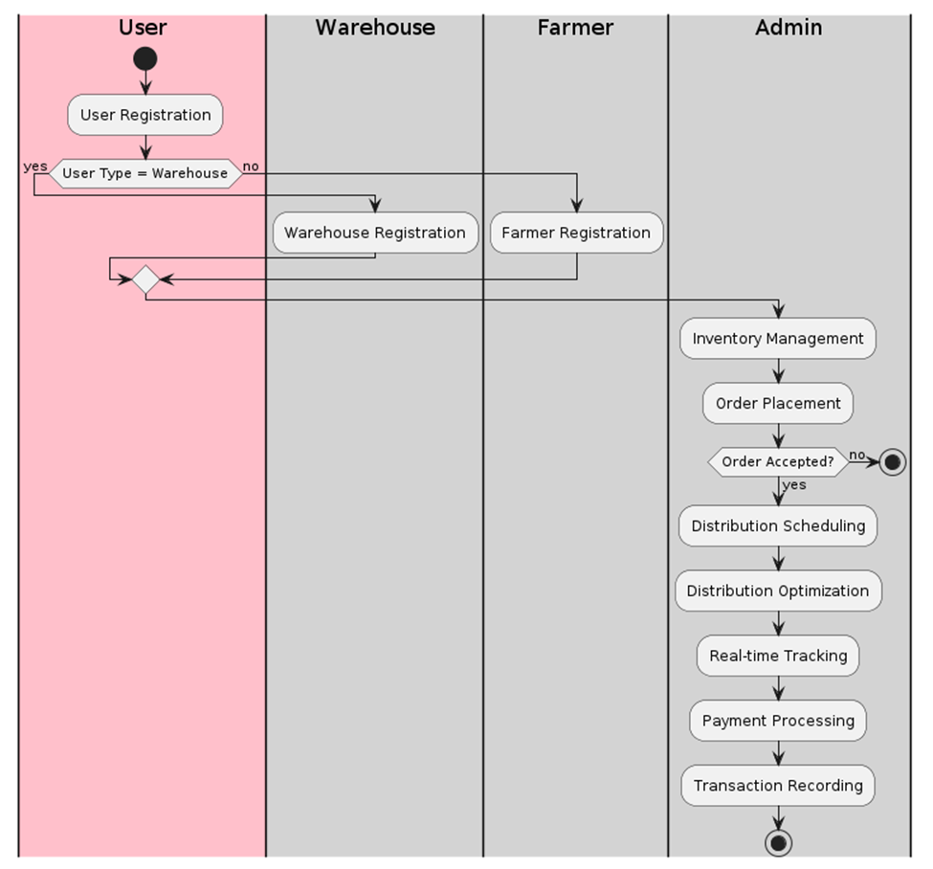
Fig: Activity Diagram
Class Diagram
The class diagram illustrates the architecture of the "Fertiware" system, a comprehensive platform designed to streamline the distribution of fertilizers. It encompasses essential entities such as User, Warehouse, Farmer, Inventory, Order, Transaction, Vehicle, Route, and Role. Each entity encapsulates specific attributes and functionalities tailored to its role in the fertilizer distribution process. Users, differentiated as warehouse administrators or farmers, engage with the system for registration and management purposes. Warehouses manage their inventory and transaction processes, while farmers place orders for fertilizer. Transactions are recorded systematically, and delivery routes are optimized for efficient distribution through vehicles. Roles within the system, such as warehouse administrators, are defined and managed accordingly. The diagram visually represents the interconnectivity and collaboration among these entities, facilitating seamless operation and management of fertilizer distribution processes.
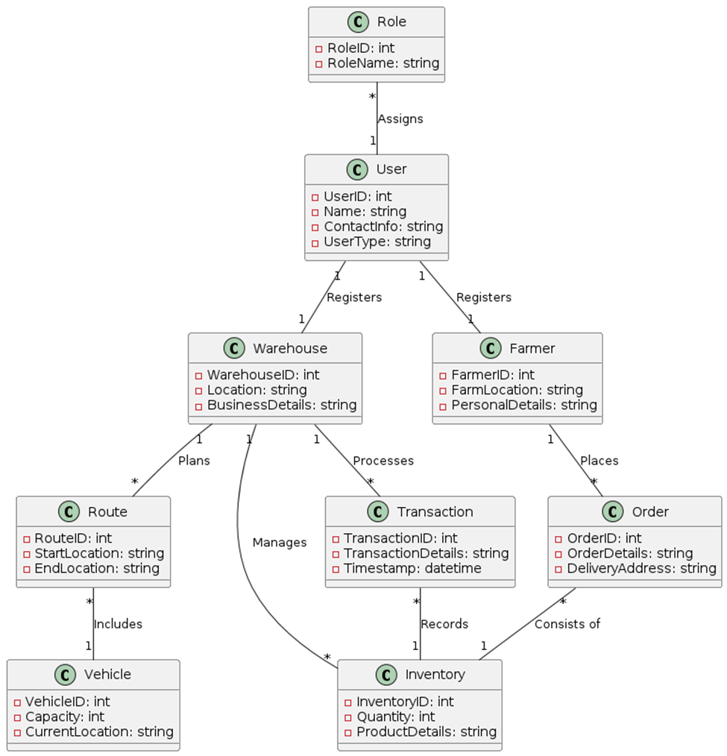
Fig: Class Diagram

Data Dictionary
Entity | Attribute | Data Type | Validation | Key
User | UserID | INTEGER | Primary Key (PK) | Primary Key
 | Name | STRING | Required, Maximum Length: 255 characters
 | UserType | STRING | Required, Maximum Length: 255 characters
Warehouse | WarehouseID | INTEGER | Primary Key (PK) | Primary Key
 | Location | STRING | Required, Maximum Length: 255 characters
 | BusinessDetails | STRING | Required, Maximum Length: 255 characters
Farmer | FarmerID | INTEGER | Primary Key (PK) | Primary Key
 | FarmLocation | STRING | Required, Maximum Length: 255 characters
 | PersonalDetails | STRING | Required, Maximum Length: 255 characters
Inventory | InventoryID | INTEGER | Primary Key (PK) | Primary Key
 | Quantity | INTEGER | Minimum Value: 0
 | ProductDetails | STRING | Maximum Length: 255 characters
Order | OrderID | INTEGER | Primary Key (PK) | Primary Key
 | OrderDetails | STRING | Maximum Length: 255 characters
 | DeliveryAddress | STRING | Required, Maximum Length: 255 characters
Transaction | TransactionID | INTEGER | Primary Key (PK) | Primary Key
 | TransactionDetails | STRING | Maximum Length: 255 characters
 | Timestamp | DATETIME | Required
Vehicle | VehicleID | INTEGER | Primary Key (PK) | Primary Key
 | Capacity | INTEGER | Minimum Value: 0
 | CurrentLocation | STRING | Maximum Length: 255 characters
Route | RouteID | INTEGER | Primary Key (PK) | Primary Key
 | StartLocation | STRING | Required, Maximum Length: 255 characters
 | EndLocation | STRING | Required, Maximum Length: 255 characters
Role | RoleID | INTEGER | Primary Key (PK) | Primary Key
 | RoleName | STRING | Required, Maximum Length: 255 characters

UI/UX Design Specification

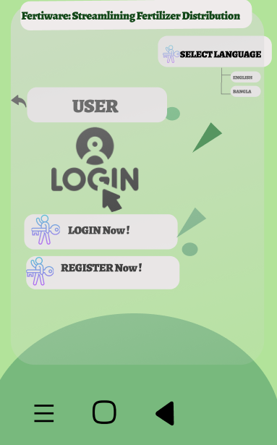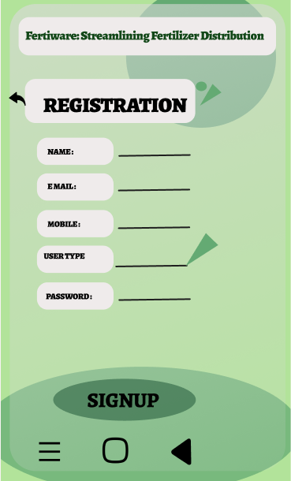
Login/Registration Registration

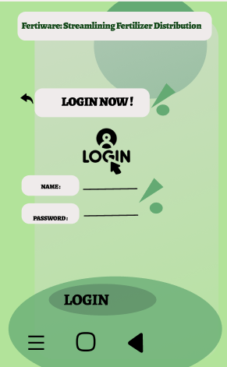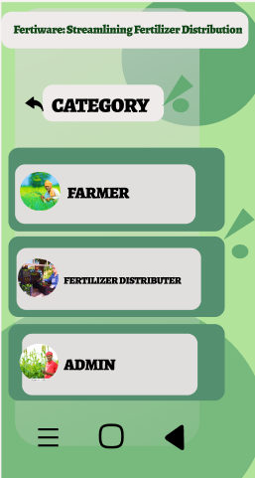
LOGIN LOGIN CATRGORY

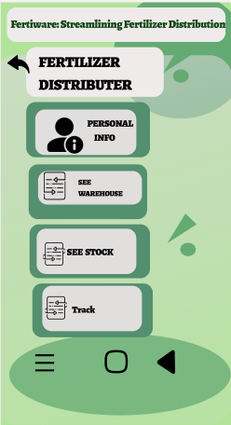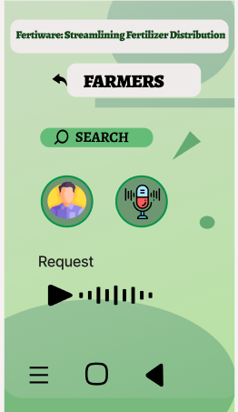
Distributer Farmer

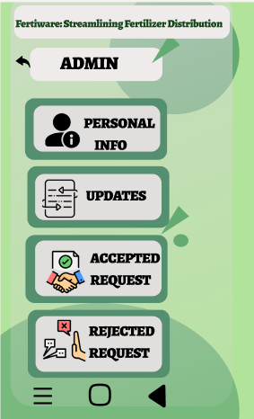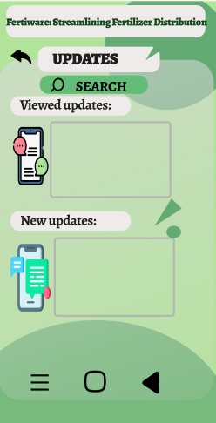
Admin Admin View (update)
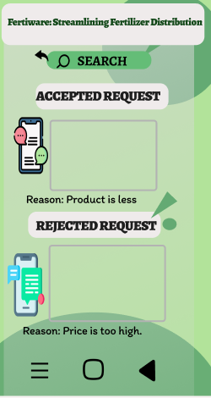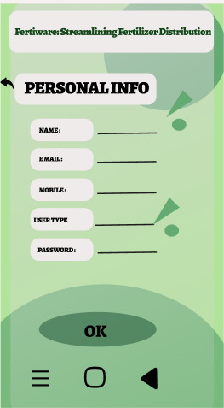
Admin View (Accepted and rejected view) Admin View (Personal Info)

Figure: UI/UX Design by Figma tool

